**Air Pollution Monitoring System Using IoT**

**Cercuit Diagram:**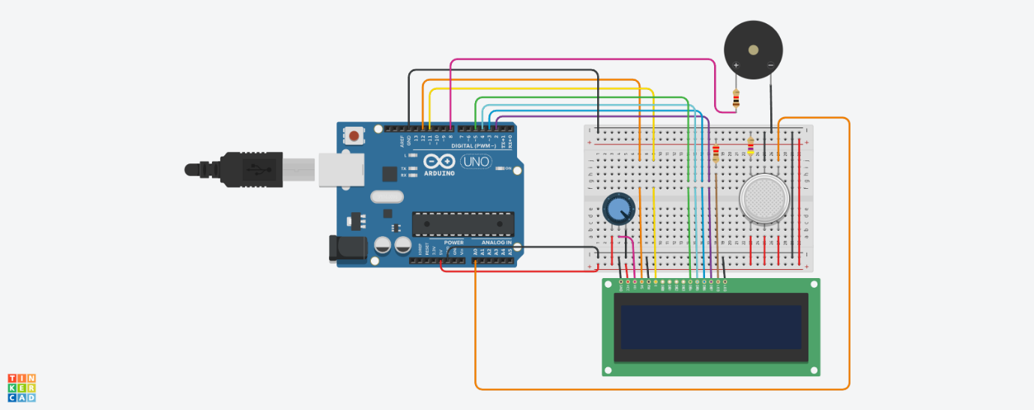

**Code:**

**// include the library code:**

**#include <LiquidCrystal.h>**

**// initialize the library with the numbers of the interface pins**

**LiquidCrystal lcd(12, 11, 5, 4, 3, 2);**

**int pin8 = 8;**

**int analogPin = A0;**

**int sensorValue = 0; // store the value read**

**void setup() {**

**pinMode(analogPin, INPUT);**

**pinMode(pin8, OUTPUT);**

**// set up the LCD's number of columns and rows:**

**lcd.begin(16, 2);**

**// Print a message to the LCD.**

**lcd.print("What is the air ");**

**lcd.print("quality today?");**

**Serial.begin(9600);**

**lcd.display();**

**}**

**void loop() {**

**delay(100);**

**sensorValue = analogRead(analogPin); // read the input pin**

**Serial.print("Air Quality in PPM = ");**

**Serial.println(sensorValue); // debug value**

**lcd.clear();**

**lcd.setCursor(0,0);**

**lcd.print ("Air Quality: ");**

**lcd.print (sensorValue);**

**if (sensorValue<=500)**

**{**

**Serial.print("Fresh Air ");**

**Serial.print ("\r\n");**

**lcd.setCursor(0,1);**

**lcd.print("Fresh Air");**

**}**

**else if( sensorValue>=500 && sensorValue<=650 )**

**{**

**Serial.print("Poor Air");**

**Serial.print ("\r\n");**

**lcd.setCursor(0,1);**

**lcd.print("Poor Air");**

**}**

**else if (sensorValue>=650 )**

**{**

**Serial.print("Very Poor Air");**

**Serial.print ("\r\n");**

**lcd.setCursor(0,1);**

**lcd.print("Very Poor Air");**

**}**

**if (sensorValue >650) {**

**// Activate digital output**

**digitalWrite(pin8, HIGH);**

**}**

**else {**

**// Deactivate digital output**

**digitalWrite(pin8, LOW);**

**}**

**}**